**Tema 3 de laborator**

9) De câte ori a împrumutat un membru (nume și prenume) fiecare film (titlu)?

SELECT m.last_name, m.first_name, t.title, COUNT(*)

FROM rental r

RIGHT JOIN title_copy tc ON r.title_id = tc.title_id AND r.copy_id = tc.copy_id

RIGHT JOIN title t ON t.title_id = tc.title_id

CROSS JOIN member m

GROUP BY m.last_name, m.first_name, t.title;

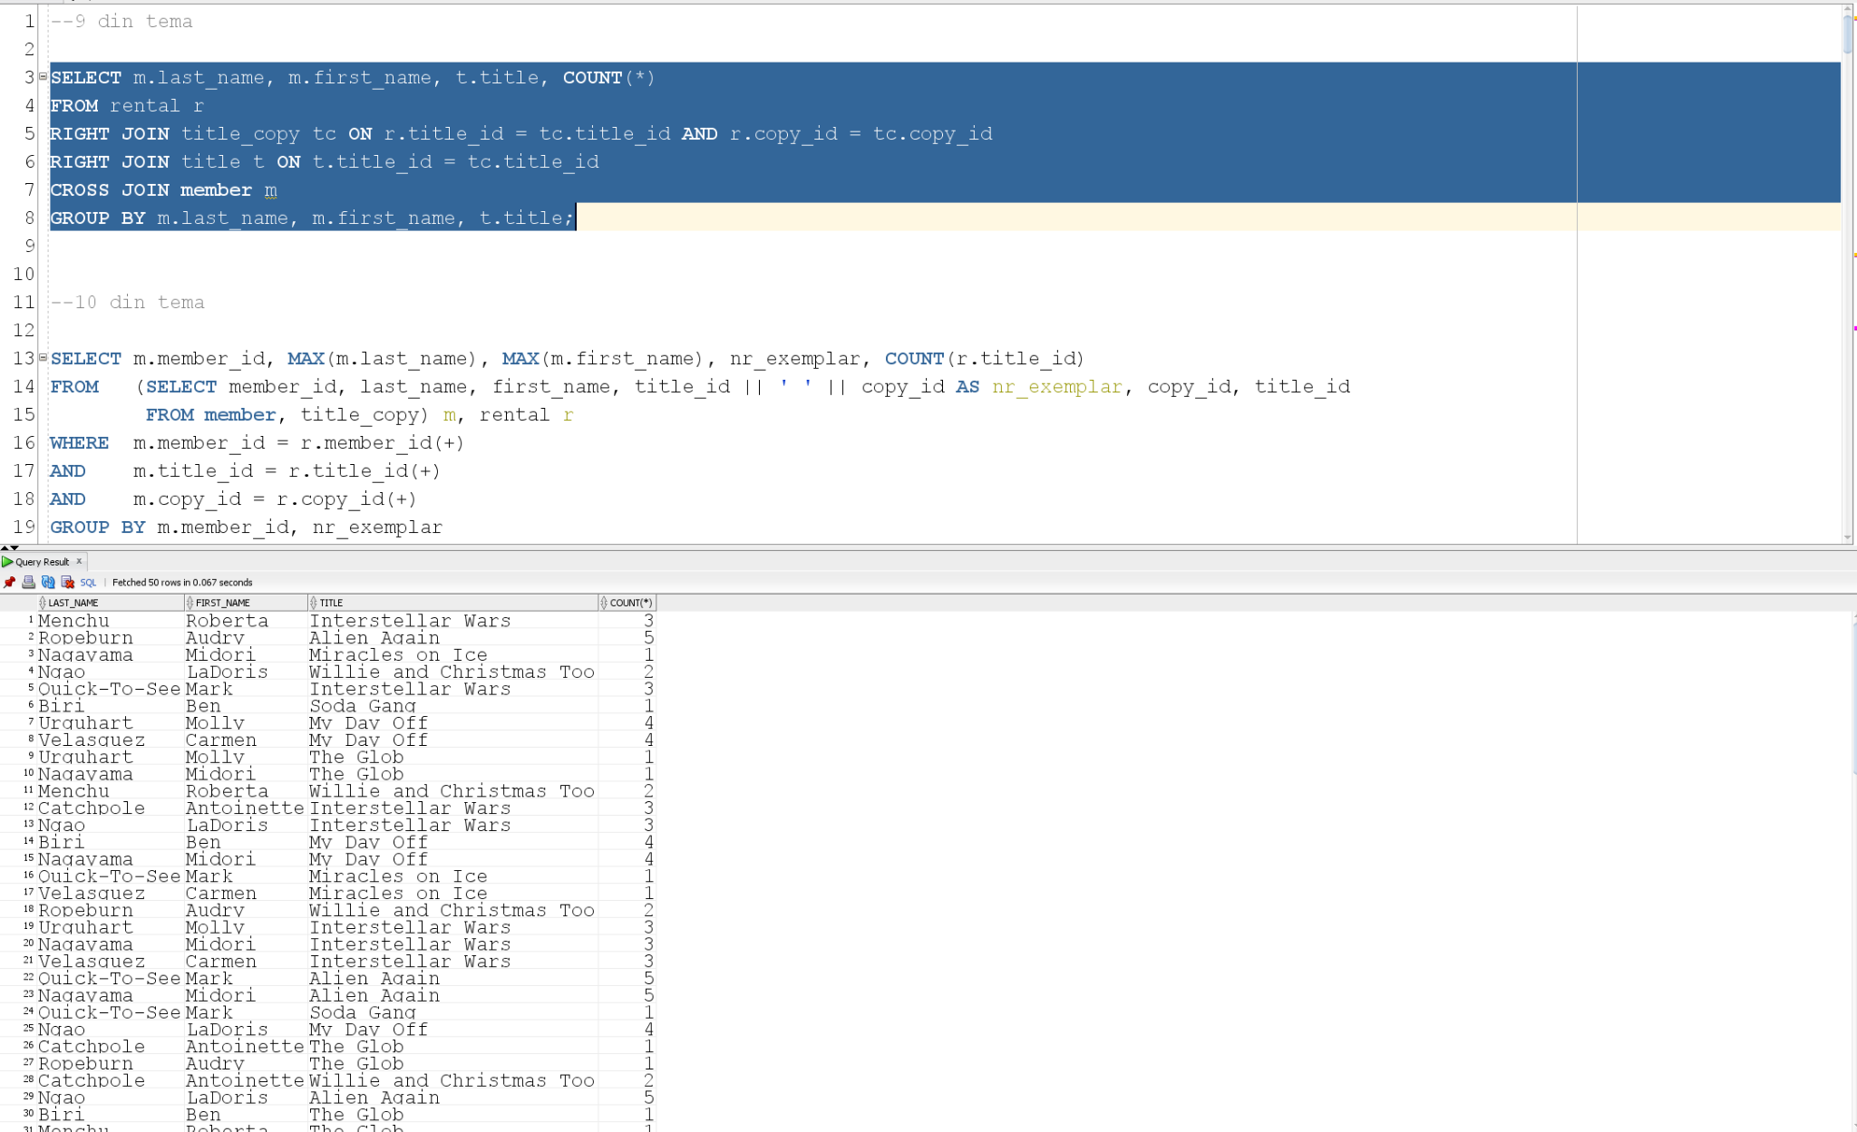

10) De câte ori a împrumutat un membru (nume și prenume) fiecare exemplar (cod) al unui film (titlu)?

SELECT m.member_id, MAX(m.last_name), MAX(m.first_name), nr_exemplar, COUNT(r.title_id)

FROM (SELECT member_id, last_name, first_name, title_id || ' ' || copy_id AS nr_exemplar, copy_id, title_id

FROM member, title_copy) m, rental r

WHERE m.member_id = r.member_id(+)

AND m.title_id = r.title_id(+)

AND m.copy_id = r.copy_id(+)

GROUP BY m.member_id, nr_exemplar

ORDER BY 1,4;

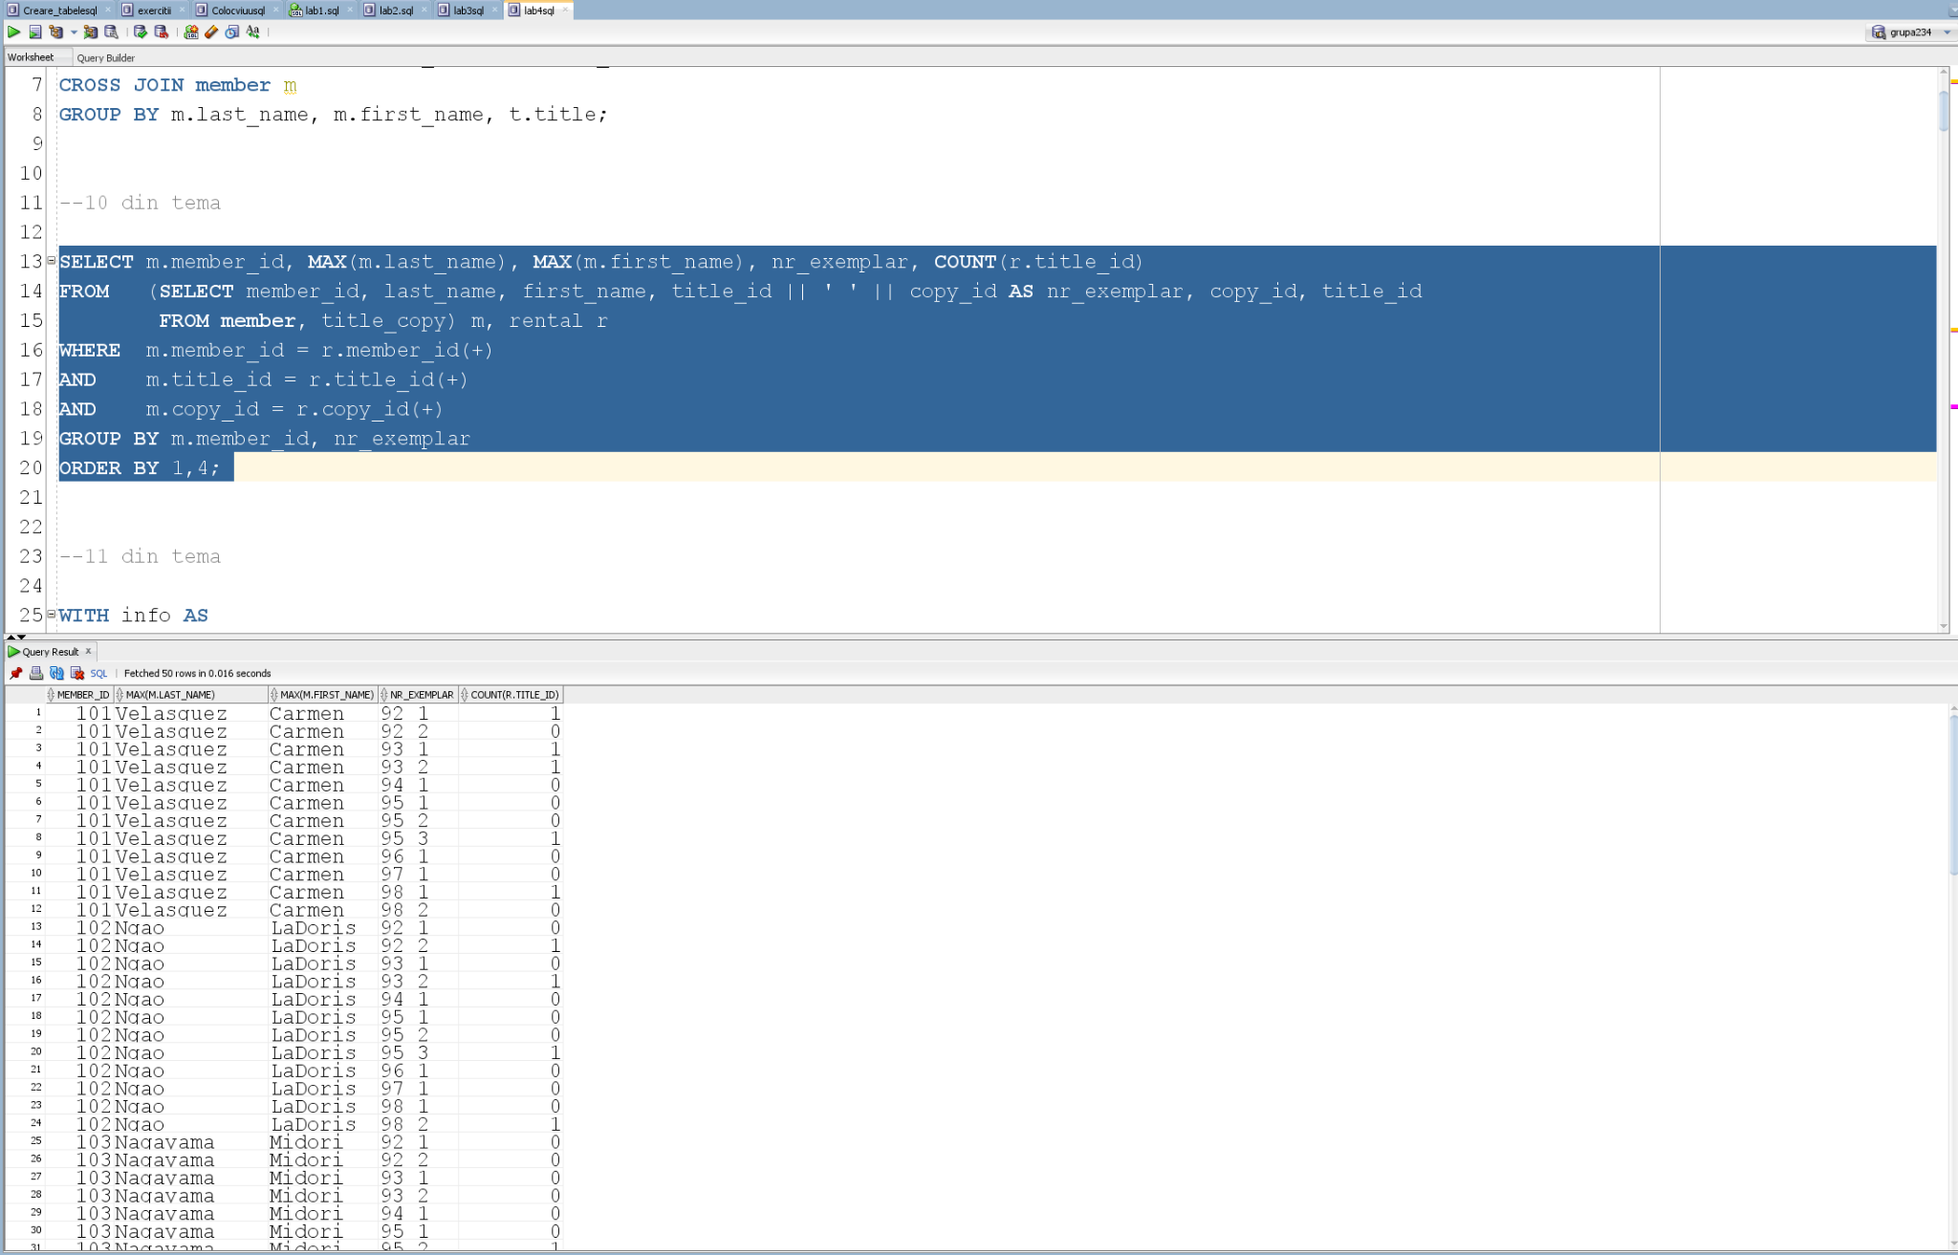

11) Obțineți statusul celui mai des împrumutat exemplar al fiecărui film (titlu).

WITH info AS

(SELECT t.title_id, MAX(title), c.copy_id, MAX(status), COUNT(*) nr

FROM title t, title_copy c, rental r

WHERE t.title_id = c.title_id

AND c.copy_id = r.copy_id

AND c.title_id = r.title_id

GROUP BY t.title_id, c.copy_id)

SELECT *

FROM info i

WHERE nr = (SELECT MAX(nr)

FROM info

WHERE title_id = i. title_id)

ORDER BY 1;

